MODULE 1B PART A: STUDENT FACTSHEET – SOURCES OF BEEF – THE SUCKLER HERD

A substantial part of this work is based on Hybu Cig Cymru (www.hccmpw.org.uk)
The following booklets by Hybu Cig Cymru are important:-
- Profitable Beef Breeding (http://www.hccmpw.org.uk/medialibrary/publications/Profitable%20Beef%20W.pdf )
- Bull Buyers’ Guide (http://www.hccmpw.org.uk/medialibrary/publications/Llawlyfr%20Prynu%20Tarw_1.pdf )
- Making the Most of Your Suckler Herd (http://www.hccmpw.org.uk/medialibrary/publications/Succler%20cows%202007%20Cym%20web.pdf )

introduction
The aim of a system which uses suckler cows, is to produce one calf from one cow every year in the most cost-effective way.

The main factors influencing the herd’s production are:-
- Increasing the number of weaned calves (dependent on number of cows in calf, number of live calves)
- Short calving period
- Prolonging the cow’s lifetime
- Using a bull with high Estimated Breeding Values (EBV). (EBV is the measure of a bull’s genetic value in terms of economic factors). It is identified as an index number - the higher the number, the better the bull
- Reducing variable costs e.g. concentrates, veterinary
- Reducing fixed costs e.g. labour, energy
Lowland Herd v Upland Herd

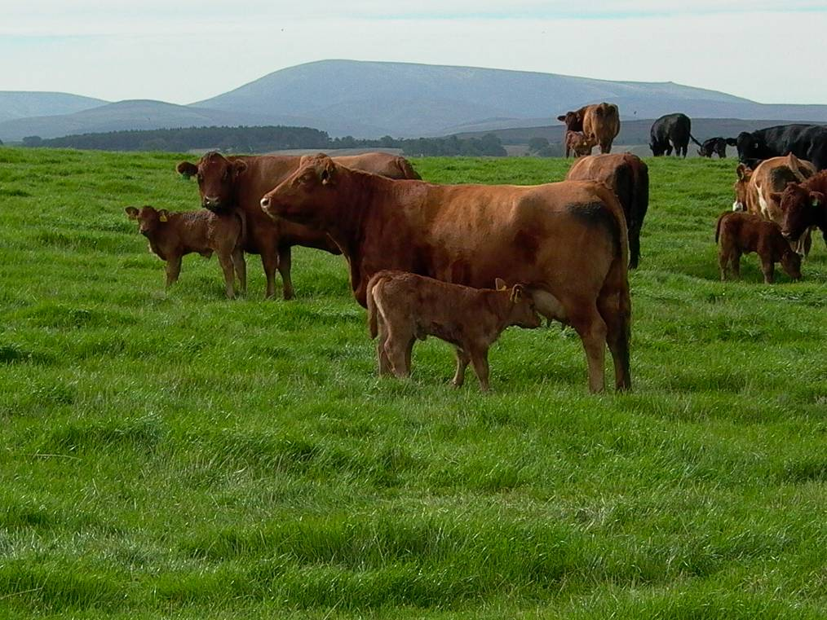
[Photo: lowland herd]
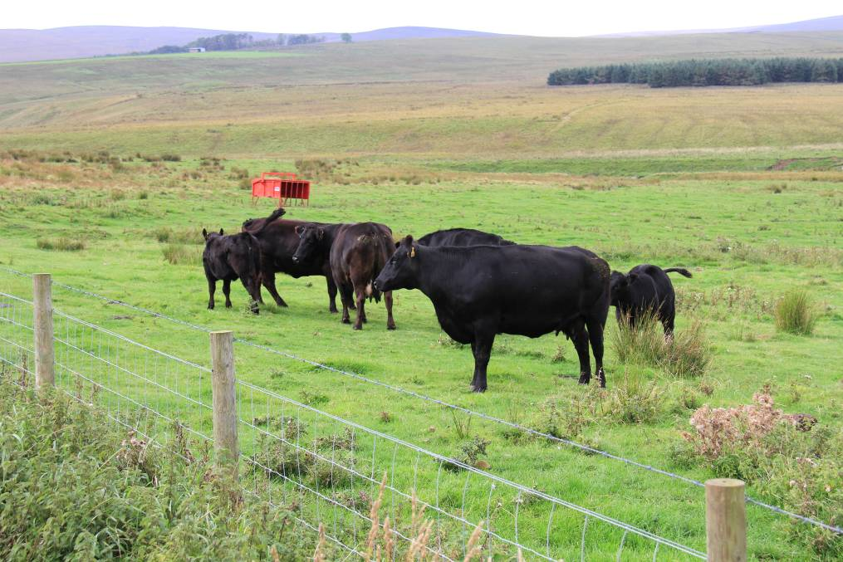
[Photo: upland herd]

Lowland | Upland
- Lack of subsidies, reducing income, a risk  - Using cattle from heavier breeds (continental) to produce bigger calves  - Use of concentrates substantially higher | - Calving in spring more suitable, due to lack of fodder for winter  - Subsidies traditionally higher, and continued with the Single Payment calculated on historical basis. Following changes to the Common Agricultural Policy this will cease in 2014.  - Indigenous breeds more popular because of their ability to use poor quality grass

Factors to Consider when choosing a cow
According to basic principles of rearing suckler calves, a cow has to possess maternal instincts to care for and rear the calf; has to be in milk, which will provide the best possible nutrition for the calf; and must have a good nature, so as to be easily managed.
Choice of the cow’s breed or cross breed will depend on the farm’s circumstances and on the system adopted. The breed’s shortcomings and merits must blend with the production environment.
Nature of Breed |  | Nature of system
- Daily growth  - Dead weight  - Use of grass  - Milk yield  - Fat and maturity | ↔ | - Availability of grass  - Availability of winter fodder (silage and hay)  - Cost and availability of concentrates  - Cost of labour  - Buildings available

Different breeds of cattle will be suitable for different systems.
Cow | Notes
Continental or cross continental | - Heavy cattle with high energy needs  - High requirements  - Feed  - Concentrates  - Buildings  - Labour  - Produces large calves, higher market value
Indigenous | - Maternal  - Uses poor quality feed  - Possible to winter outside inexpensively
Cross milking cow | - Combines a high milk yield with the merits of beef breeds

[Photo: Cows of different Pure breeds – Welsh Black Cattle, Aberdeen Angus, Hereford, Limousin, Charolais; Cross – ¾ Continental, HerefordxMilking, Continentalx Milking]
[See Profitable Beef Breeding page. 32 para 6.1 & 6.2]

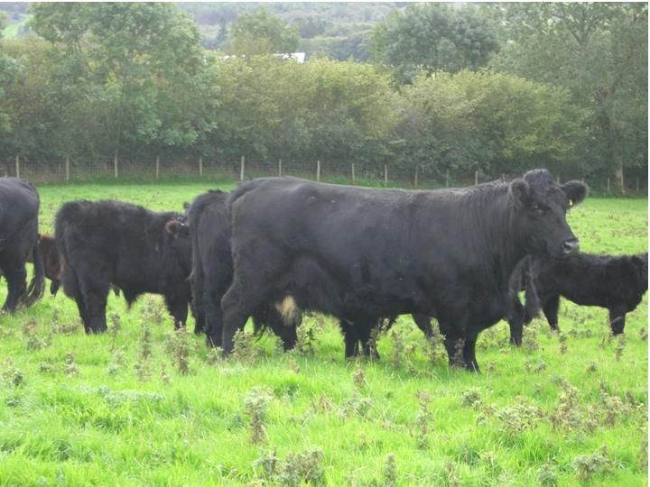
[Llun : Welsh Black cow]
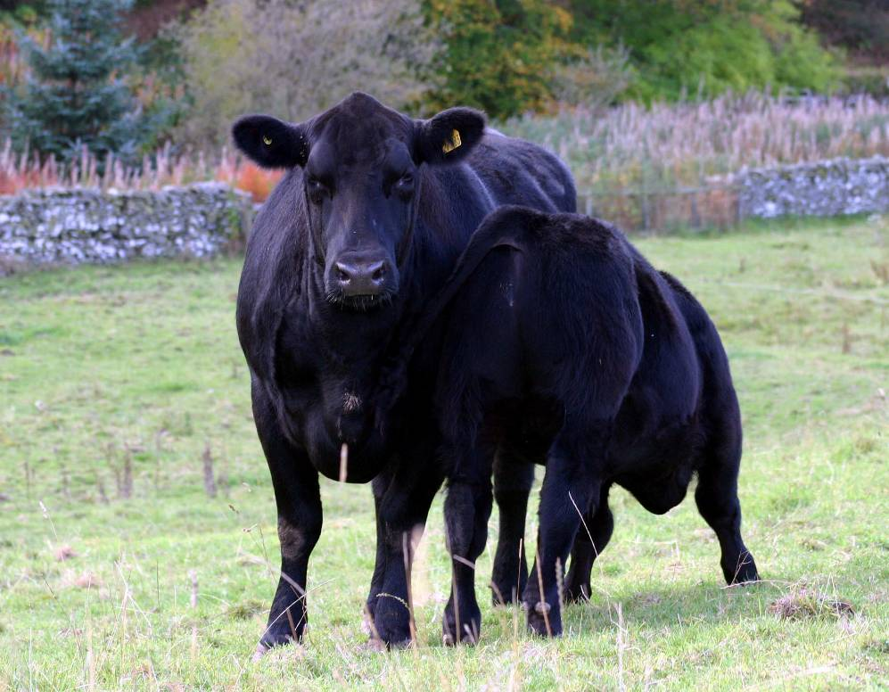
[Llun : Aberdeen Angus Cow and calf]

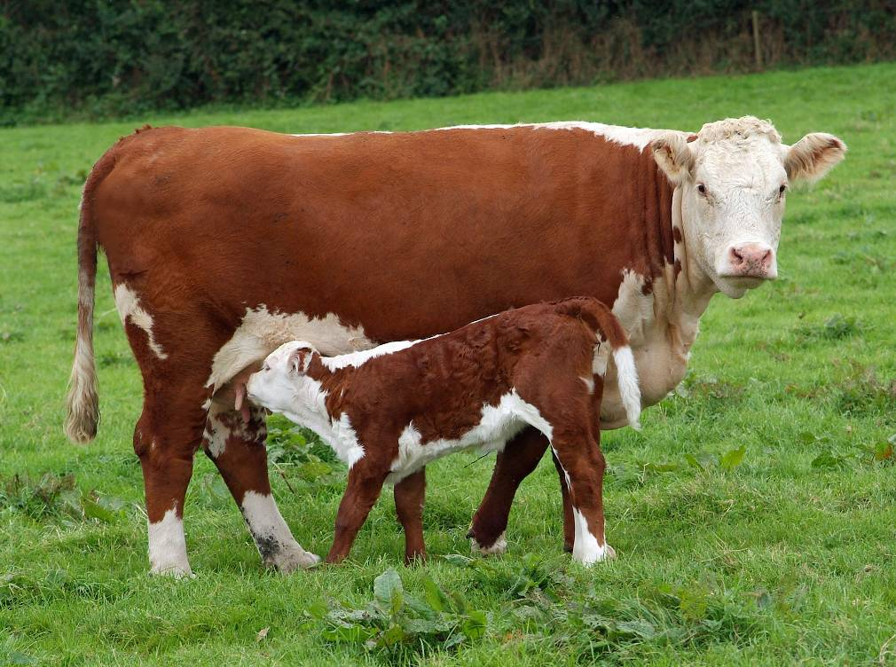
[Llun : Hereford Cow and calf]
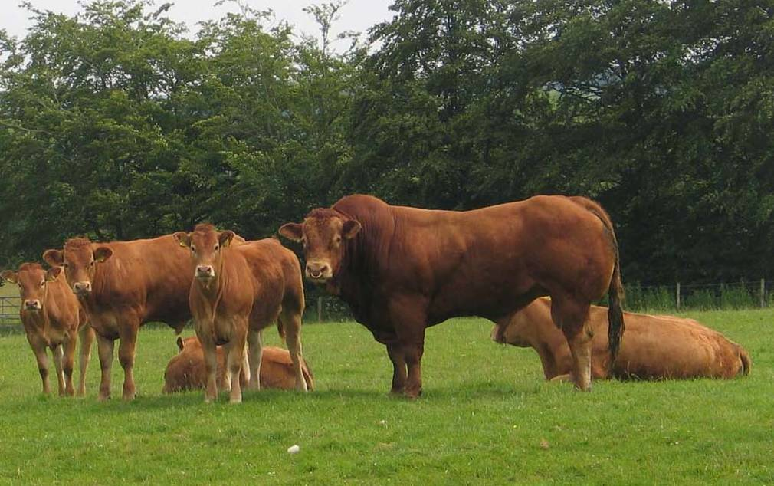
[Llun : Limousin Bull, Cow and calf]

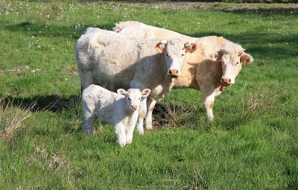
[Llun : Charolais Cow and calf]

Fertility of the herd
[ See Profitable Beef Breeding page. 15 para 3.1-3.5]

Production Cycle Blueprint

Suckler cow
Calving
Service
In calf
9 months
Weaning
Calving
Steers and bulls
Heifers
Choose the right bull
Cattle sold as stores
Cattle sold finished
Finishing system
Replacement heifers
Service
2 mths
< 3 mths
12 mths
In calf
9 months
Rearing calf

herd management

[See Making The Most of Your Suckler Cows]
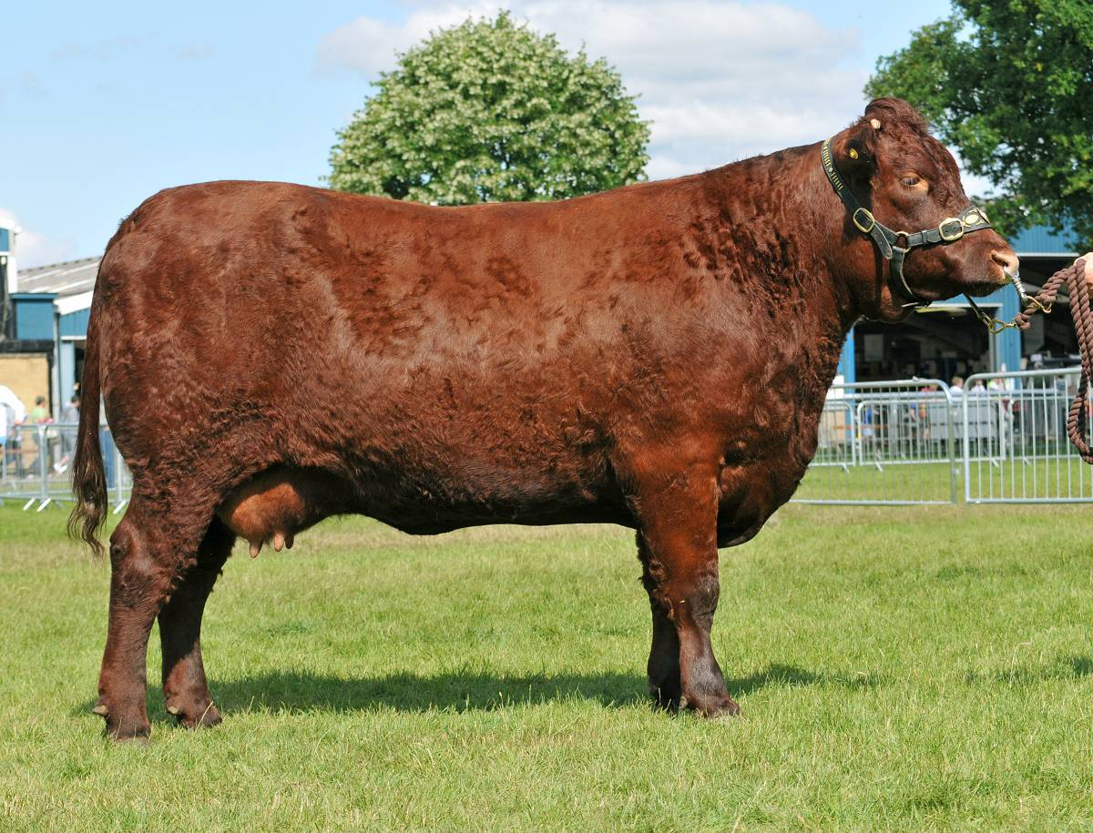
[Photo: an overfat cow (CS5) ]

choosing a bull
Before choosing a bull, the purpose and the end product of the suckler herd must be decided. Usually, there are three choices
- Produce suckler calves to sell
- Finish suckler calves
- Produce replacement heifers
The system could also be a combination of the above by choice or by accident. If a farmer chooses to operate a system for 3 differing purposes then the management of such a system would be more difficult as a number of main objectives would conflict e.g.
- Milky breeds used to produce replacement heifers do not have a conformation suitable for producing animals for finishing systems;
- Heifers from breeds with good conformation could develop increased levels of dystocia;
In addition a farmer can be put in the same position by chance when buying a bull with one objective in mind and having calves that grow well being finished, slow growing calves being suitable only to be sold as stores and also having some heifers suitable as replacements.
A farmer has to consider some general features when choosing a bull, for example
- Temperament
- Locomotion
- Longevity
- The breed’s features
- Size
but he will also consider specific features that change according to the system’s purpose. These can be measured by using EBV.
Produce suckler calves to sell | Finish suckler calves | Produce replacement heifers
Ease of Calving | Ease of Calving | Ease of Calving
Birth Weight | Birth Weight | 200 days’ growth
200 days’ growth | 400 days’ growth | 400 days’ growth
Muscle density/surface | Muscle density/surface | 200 days’ milk
 | Fat Density
As regards heifers, the EBV, gestation period and weight of new born calf have to be considered.
TablE 1 : BULL Features ACCORDING to FUNCTION OF SYSTEM
(adapted from Breeding a Profitable Beef Herd by HCC, where there are further notes)
[See Breeding a Profitable Beef Herd p. 5 par. 2.1-2.6]
[See the booklet Buying a Bull]

Description of the calves produced (gender, breed, size, quality)
Some specific traits influence a beef animal’s response within the production system. These traits are innate, and very often belong to the breed. They affect growth, weight and quality of the carcass. Animals of different breeds respond in different forms.

the Effect of gender
A bull will grow faster and develop a heavier weight than a bullock, and a bullock will likewise grow faster and develop a heavier weight than a heifer. The male hormones (testosterone) that promote growth are responsible for this growth. On average, a bull will grow 150-200g/day more than a bullock or heifer. These differences are estimated to be about 10%.
[Activity: Compare a Heifer, Steer and Bull of the same age and assess the body shape sideways and from the back]

age
Kg weight
bull
heifer
steer
~10%
~10%
Figure 1 age and weight relationship for beef animals of different genders
Gender also influences the quality of carcass, and the quantity of body fat. When comparing beef animals of the same age, the heifer will have more fat than either the bullock or bull. Therefore, the heifer will reach a fat level suitable for market at a lower weight than the bullock and bull.
weight
% fat
heifer
bull
steer
Market requirement

Figure 2 weight and fat relationship for beef animals of different genders

maturity
Maturity is defined as the time the animal takes to develop layers of fat on its body. Heifers mature earlier than bullocks and bulls, but maturity is also influenced by the animal’s breed. Indigenous breeds such as the Hereford and the Aberdeen Angus mature earlier than continental breeds such as the Limousin, Charolais and Simmental. The basis of the continental breeds’ popularity, is that they can reach a higher weight without becoming too fat. A higher level of nutrition will accelerate the process of developing fat on the body, and hasten the maturity process. If a farmer chooses a low nutritional system, and animals that mature late, it is possible that they won’t develop enough body fat to satisfy market needs. Likewise, if an animal that has matured too early is put on a high nutritional system, it could reach the market with a weight that is far too light.

age
weight
● Hereford
● Charolais
● Angus
● Welsh Blacks
● Blonde
● Simmental
● Limousin
● Stabiliser
● Belgian Blue
● Galloway
● South Devon
Late maturing at heavier weights

Early maturing at lower weights

Figure 3 breed’s weight v age on constant fat level (3H)

% fat
Late maturing – lower plane of nutrition

weight

Late maturing – high plane of nutrition

Early maturing – lower plane of nutrition

Early maturing – high plane of nutrition
Market requirements

Figure 4 Relationship between fat, maturity and weight in beef animals

carcass Quality

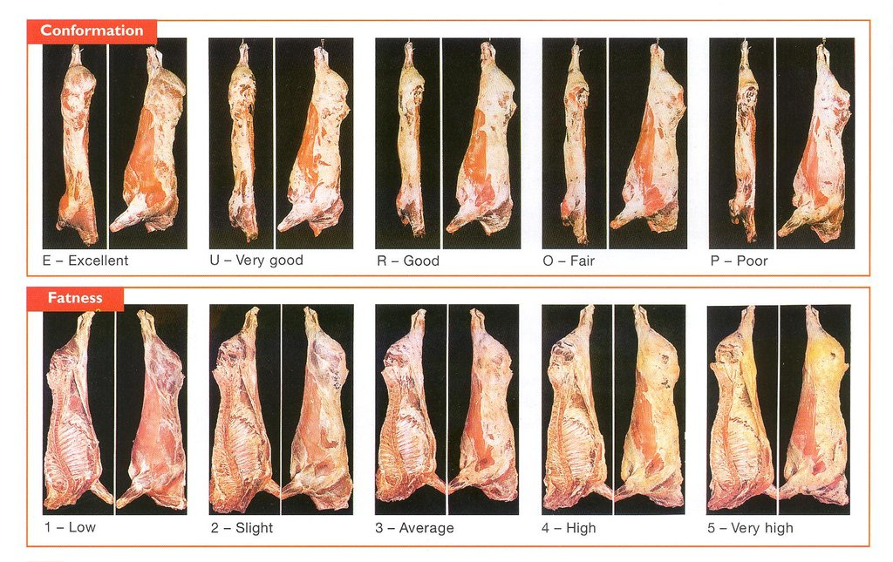
Figure 5 differing carcass quality in the abbatoir
The choice of breed will affect the quality of the carcass. On the whole, the continental breeds mature later and have a better conformation. The indigenous breeds mature earlier and have a higher fat level. This could be advantageous when feed is scarce. Since milking breeds are chosen for milk production, an angular shape would appear to be a poor conformation. Today, the Friesian Holstein is considered to be unsuitable for producing beef because of the breed’s poor conformation.

 |  | Increasing fatness ➔
 |  | 1 | 2 | 3 | 4L | 4H | 5L | 5H
Improved conformation ➔ | E |  | Continental  breeds
Improved conformation ➔ | U+ |  |  |  | Native breeds
Improved conformation ➔ | -U
Improved conformation ➔ | R |  | Dairy  breeds
Improved conformation ➔ | O+
Improved conformation ➔ | -O
Improved conformation ➔ | P+
Improved conformation ➔ | -P

Marketing suckler calves
Traditionally, the main season for marketing suckler calves was autumn. The large number of calves coming on to the market lowered prices. Today, the difference is not as noticeable, because:-
- A greater number of calves come from the milking herd
- More feed is available in winter because of better understanding of grass growing technology
- Alternative feeds available

P per kg
-----

spring
summer
autumn
winter
Number sold
______
Figure 6 Nature of suckler calves’ supply
Many factors affect the price, including:-

- Time of year – seasonal variation in price
- Number of cattle marketed generally
- Gender – male calves of greater value than female
- Breed – continental of greater value than indigenous
- Conformation – better conformation of greater value, milking pedigree of less value
- Weight
- Body condition – cattle with a potential to gain substantial weight are of greater value
- Market issues – numbers that are sold together, probably in an enclosure

Prices of suckler calves do not necessarily correspond with fat cattle beef prices in Britain. (source DEFRA)

Further information
- Beef Producers’ Handbook “From Gate to Plate” http://www.hccmpw.org.uk/medialibrary/publications/Beef%20producers%20handbook%20Eng%202010.pdf
Beef prices vary from year to year, and from season to season. Beef prices fell considerably after the BSE problems, but have increased gradually since then due to measures to prevent BSE. In recent years there has been less beef supply and an improved beef price (Figure 6).
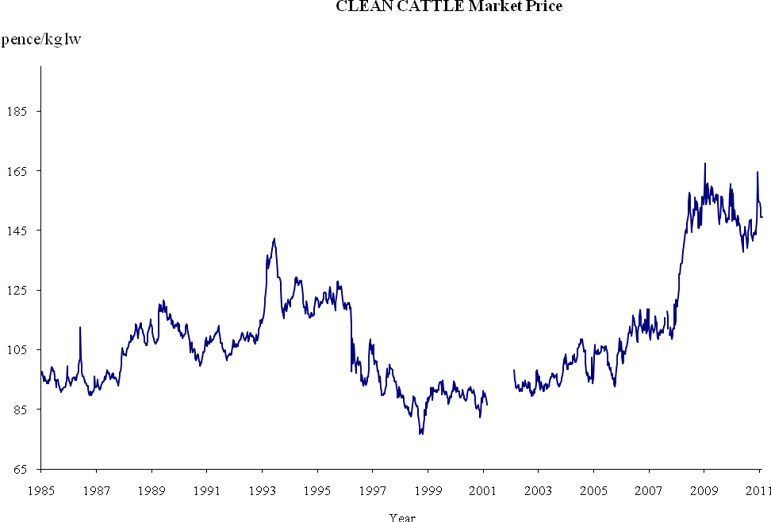
Figure 7 PriceS of fat cattle in britain 1985-2011
Traditionally, a substantial number of beef cattle are marketed in autumn as farmers anticipate a costly period of feeding during the winter months. This increases supply and the prices fall.

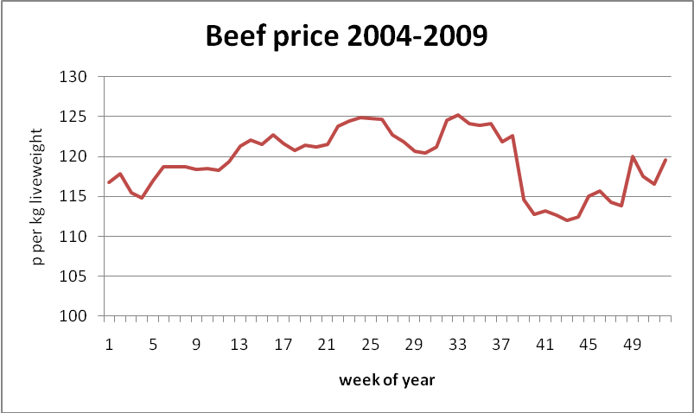

Figur 8 composite prices for the last 6 years

STRATIFIED PRICING SCHEDULE

Abattoirs often offer the basic price for beef – this is then modified according to stratified tables that reflect the carcass’s quality and value. Farmers can target animals for the market/abattoir that offer the best price.

 |  | Increase fat ➔
 |  | 1 | 2 | 3 | 4L | 4H | 5L | 5H
Conformity improving | E | +5 | +15 | +15 | +10 | -15 | -40 | -50
Conformity improving | U+ | Basis | +10 | +10 | +5 | -15 | -40 | -50
Conformity improving | -U | Basis | +5 | +5 | Basis | -15 | -40 | -50
Conformity improving | R | Basis | Basis | Basis | Basis | -15 | -50 | -50
Conformity improving | O+ | -10 | -5 | -5 | -10 | -20 | -60 | -60
Conformity improving | -O | -20 | -10 | -10 | -25 | -40 | -70 | -70
Conformity improving | P+ | -25 | -25 | -25 | -35 | -40 | -80 | -80
Conformity improving | -P | -25 | -25 | -25 | -35 | -40 | -80 | -80

Table 2 Example of STRATIFIED PRICING SYSTEM

managing costs

The key factors in operating a beef system is managing costs and increasing income.

Income |  | Main factors
 | Calves | c / kg; selling weight (kg) – effect of breed, nutrition, daily growth.
 | Old cows | c / kg; selling weight (kg); number
 | Old bulls | c / kg; selling weight (kg)
Variable costs
 | Concentrates for cow | £ / ton; kg per head per day; feeding period (day)
 | Concentrates for calf | £ / ton; kg per head per day; feeding period (day)
 | Straw | £ / ton; tonnes used
 | Veterinary | £ per head; general health
 | Marketing costs | Standard
 | Grazing costs | Stock density; fertilizer costs
Other income
 | Single Payment | Historical

Table 3 Factors to consider with a suckler herd as regards cost and income

Adaptations to the system – breeds, feeding and calving season, artificial insemination¸ multi-calf suckler system, managing the calving period (short as possible)

Changing cow breed – effect on calf’s size, use of grass
Cow Breed | Continental | Indigenous
Advantages | - Heavier calves  - Better conformation | - Use poor-quality grass  - Higher stock density  - Outside wintering
Disadvantages | - Use more feed  - Lower stock density  - Extensive buildings and feed stores required | - Smaller calves for market  - Less conformation standard

Changing the calving season – necessary feeds, stock density, marketing calves
Calving season | Spring | Autumn | Throughout the year
Advantages | - Cow’s high energy requirements corresponds with grass growing season  - Cheap grass available to feed herd  - Higher stock density  - Calves’daily growth higher (kg/day)  - Natural period for calving | - Calves heavier in Autumn auctions  - Income from calves higher  - Possible to control cow’s nutrition better | - Suitable for a pedigree herd where production of live calves is important
Disadvantages | - Calves too young to graze the nutritious spring grass  - Calves’ weight lower at selling period 6-10 months old | - Unsuitable when feed is limited  - Extensive building required for the herd and to store silage  - Higher labour costs  - Higher variable costs, especially concentrates for cows and calves | - Fluctuating production –difficult to plan for market  - Difficulty controlling groups within the herd

Bull or Artificial Insemination – advantages and disadvantages

Breeding | Natural | Artificial Insemination
Advantages | - Bull is very good at recognizing cows in heat | - Choice of high quality bulls  - Savings on stocking a bull
Disadvantages | - Bulls are dangerous to stock | - Herd has to be nearby to recognize a cow in heat

Adoption of a multi-calf system – which type of cow, source of good quality calves
Number of calves | Singular suckler | Multi-calf sucklers
Advantages | - Cow concentrates on rearing one calf | - Increases the output of the cow to accommodate higher milk production
Disadvantages | - No product from cow if calf dies  - Shortage of milk affects the calf’s growth | - Requires a cow with a higher milk production  - Infections transmitted from calf to calf  - Buildings required

references
Red Meat Industry Forum http://www.redmeatindustryforum.org.uk/supplychain/BeefProduction.htm
http://www.redmeatindustryforum.org.uk/supplychain/SupplyChain.htm
Beef Production and Management Decisions (5 edition) by Thomas G. Field (Author), Frank E. Hagan (Author) Prentice Hall ISBN 0131198386
DEFRA The Cattle Book http://www.defra.gov.uk/foodfarm/farmanimal/diseases/vetsurveillance/reports/documents/cattlebook-2007.pdf
DEFRA Cattle Statistics
https://statistics.defra.gov.uk/esg/index/list.asp?i_id=007

